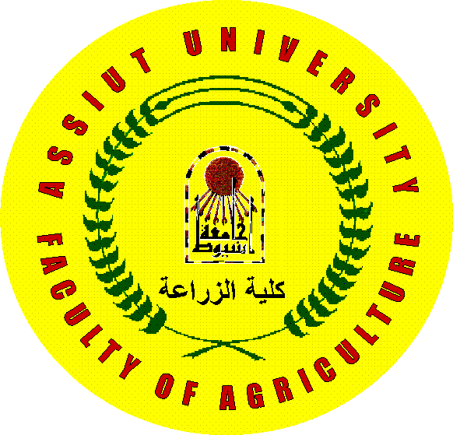 | Assiut University  Faculty of Agriculture  Plant Pathology Department | 

Curriculum Vitae

Hassan M. A. E.
Personal data:
Name: Mohamed Atala El-Saied Hassan
Place & date of birth: Kena, Egypt, 31.08.1966
Nationality: Egyptian
Marital status: Married
Position: Lecturer, in plant pathology Dept. Faculty of Agriculture, university, Assiut official Address
Official Address: Dept. of Plant Pathology, Faculty of Agriculture, Assiut
University 71526, Assiut, Egypt.
T.work:+20882412705
T. Home: +20882286621
Fax: +2 088233 13 84
Mobil.: +20121783844
E-mail: habatalasamat@yahoo.com
Academic Education:
1. B.Sc., Agricultural Science, Phytopathology, June 1988, Faculty of Agriculture, University of Assiut, Egypt.
2. M.Sc. in Agricultural Science, Phytopathology, Bacteriology, September 1994, Faculty of Agriculture, University of Assiut, Egypt. Title: Studies on bacterial blight of broad bean (Vicia Faba L.).
3- Ph. D. hohenheim university, Stuttgart, Germany: title, induction of resistance of bacterial wilt tomato cause by Clavibacter michiganensis subsp. michiganensis and to fire blight in apple caused by Erwinia amylovora.

Languages:
- First language: Arabic
- Second language: English
- Third language: Germany
Professional experience:
1989-1994: Demonstrator in the Department of Plant Pathology, Faculty of Agriculture, University of Assiut, Egypt.
1995-1999: Assistant Lecturer in the Department of Plant Pathology, Faculty of agriculture, University of Assiut, Egypt.
2000-2005: Ph.D student at the Institute of Phytomedicine, Phytopathology, Hohenheim University, Stuttgart, Germany.
2005-now: Lecturer, Dept. of plant pathology, Faculty of Agriculture, Assiut University.
Scientific activity:
- Teaching as Assistant for B.Sc. and postgraduate in General Phytopathology and teaching the practical work of Plant Bacteriology.
- Participation in the Summer Training Program (Faculty of Agriculture, University of Assiut) for junior students.
- German Language Course at Goethe Institute, Schwäbisch Hall, Germany.
- Acceptance exams at University of Hohenheim, Stuttgart, Germany.
- Training Course and workgroup in Hohenheim University, Stuttgart, Germany, Molecularbiology techniques in the period from 23/07/2001 to 3/08/2001. Isolation and transformation of Escherichia coli.
- Training course on Electron Microscopy (Techniques & Interpretations.) in the period from 26-31/3/2005.
- Water & Waste conference June 3 to 6- 2007 Assiut Univ., Assiut Egypt.
- Eleventh Conference of Plant Pathology November 27-28, 2007 Giza, Egypt.
- Training course on plant tissue culture and transformation techniques in Agricultural genetic engineering research institute (AGERI), Egypt in cooperation with Midwest universities consortium for international activities (MUCIA) during the period from 24-02-2008 to 06-03-2008.
10) The Second scientific conference of young scientists on faculty of Agriculture Assiut Univ. 6 May 2008, Assiut Egypt
Thesis Supervisor:
- Mohamed Fathy Faiz Break (M SC)
- Hadeal Magdy Khalel (M Sc)
Projects:-
1- Integrated control of onion white rot disease from October 1989- December 1993

2- Production of potato seeds around the year through biotechnology techniques from 1/7/1996 to 30/10/1997.
3- Evaluation of Cumin and Fennel Accessions Collected from Upper Egypt to Fungal diseases, Fruit Yield and Essential oil Contents from 1/10/1994 to 30/3/1996.
4- Improvement of Seasam production in Egypt from 1/10/1994 to 30/6/1995.
5- Production of tomato and banana seedlings, free from diseases, in Dept.plant pathology, Faculty of Agriculture, Assiut University from 1/3/2007 to now.

Research Publications:
- Abd-El-Moneem, K.M.H.; F. A. Saeed; M.A. Sallam and M. A.El-Saide. 1994. Occurrence of bacterial blight of broad bean caused by Pseudomomnas syringae pv. syringae in Upper Egypt. Assiut J. of Agric. Sci. Vol. 25, No. 5: 261-274.

- Abd-El-Moneem, K.M.H.; F. A. Saeed; M.A. Sallam and M. A.El-Saide. 1994. Sugars and amino acids contents of broad bean plants in relation to infection with bacterial blight disease. Assiut J. of Agric. Sci. Vol. 25, No. 5: 275- 286.

- Hassan M.A.E and H. Buchenauer. 2007. Induction of resistance to fire blight in apple by acibenzolar-S-methyl and DL-3-aminobutyric acid. Journal of Plant Diseases and Protection. 114, 151-158.

- Hassan M.A.E and H. Buchenauer. 2008. Enhanced control of bacterial wilt of tomato by DL-3-aminobutyric acid and the fluorescent Pseudomonas isolate CW2. Journal of Plant Diseases and Protection. (Under Puplication).

References:
1-Prof. Dr. M. A. A. Sallam Plant Pathology Department, Faculty of Agriculture Assiut Unive., Egypt
2- Prof. Dr. M. H. A. Hassan Plant Pathology Depart, Faculty of Agriculture Assiut Unive., Egypt
3- Prof. Dr. H. Buchenauer Institut für Phytomedizin (360), University of Hohenheim, 70593 Stuttgart, Germany.

